AI WEATHERWISE
DELIVER INTELLIGENT WEATHER FORECASTS AND INSIGHTS.

Description
AI WeatherWise is a robust RESTful backend platform developed using Node.js and Express.js, with MongoDB and Mongoose for reliable data storage and management. It provides real-time weather information and integrates Google Gemini AI to generate intelligent weather summaries and personalized recommendations based on current environmental conditions.
The system includes JWT-based authentication, bcrypt password encryption, and APIs for managing users, favorite locations, weather data, and AI-powered insights. It also provides fallback functionality, centralized error handling, and request sanitization to ensure reliable, secure, and efficient API performance..
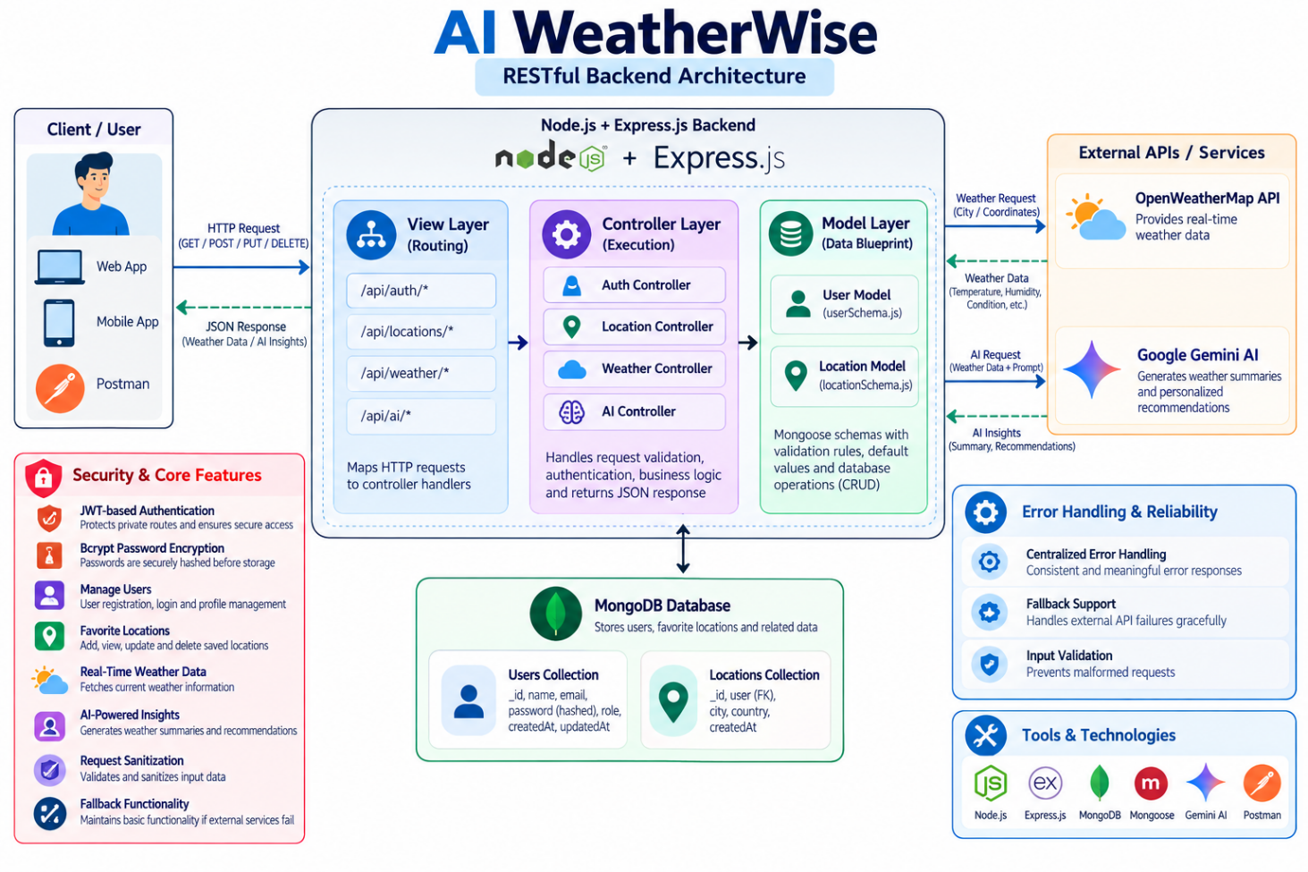

Scenario-Based Case Study

Background

Alex is a frequent traveler who plans trips to different cities and often needs to understand the weather conditions before going out. Instead of checking multiple weather sources and interpreting technical weather data, Alex wants a single platform that provides current weather information along with simple, intelligent suggestions. AI WeatherWise helps Alex monitor weather conditions for different locations and receive AI-generated insights for better travel and daily activity planning.Problem
- Difficulty tracking and managing multiple favorite weather locations efficiently.
- Lack of personalized recommendations for outdoor activities or clothing.
- Need for natural language weather summaries rather than just raw data metrics.
- Absence of a secure system to store and sync preferences across devices.

Solution

AI WeatherWise provides a centralized backend service for retrieving real-time weather information and generating AI-powered insights. It securely manages user accounts and favorite locations using MongoDB and Mongoose, while Google Gemini AI generates meaningful weather summaries and personalized recommendations based on current conditions.Usage
- User Usage: Manages favorite cities (CRUD), fetches real-time weather, and requests AI insights for recommendations and summaries.
- Developer/Admin Usage: Monitors API health, manages global user registrations, and verifies weather/AI service integrations.
- Weather Application User: Interfaces with the public weather endpoints to consume current metrics without requiring an account.
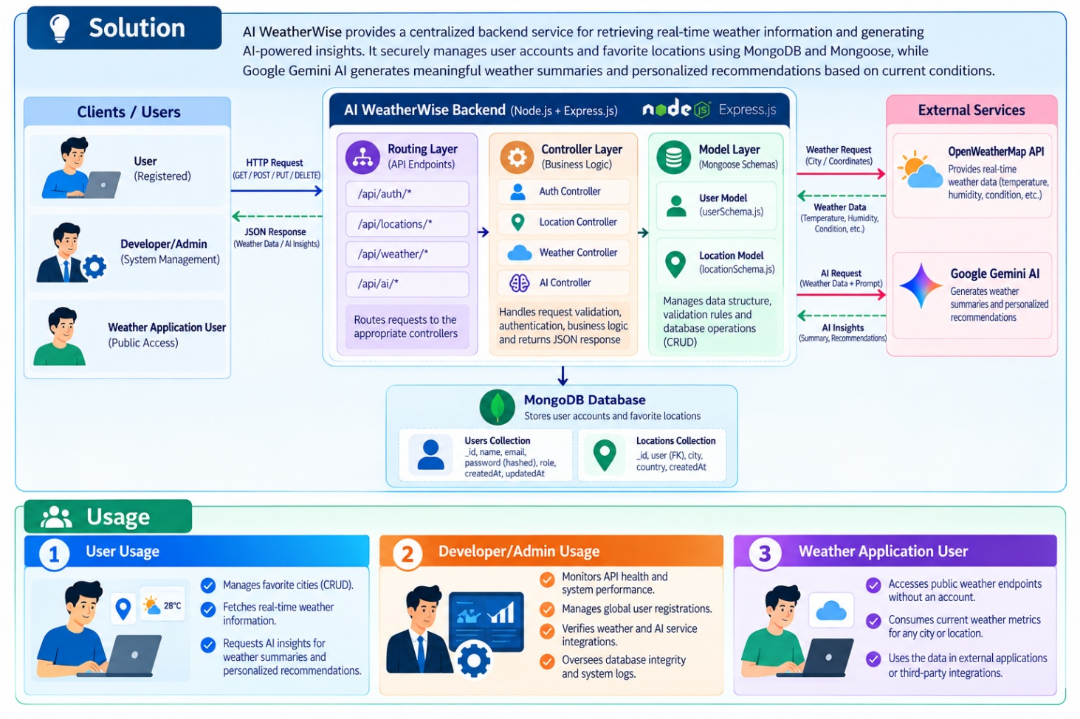

Outcome
By leveraging AI and centralized data management, users spend less time deciphering raw metrics. The system ensures data integrity via Mongoose schemas and provides high-value, context-aware weather advice through Gemini integrations.

1. Software Requirements
- Operating System: Windows 10/11, macOS, or Linux (supports cross-platform operations).
- Node.js (v16 or above): Runtime ecosystem running server logic and routing infrastructure.
- npm (v8 or above): Node package manager to control operational dependencies.
- Gemini AI SDK: Integration using @google/generative-ai for natural language insights.
- MongoDB: Document NoSQL engine storing users, posts, categories, comments, and analytics metrics.
- Postman: API verification toolkit to assert schema validation responses across administrative route shields.
- Code Editor: Visual Studio Code or similar IDE environment.

2. Hardware Requirements
- Processor: Intel Core i5 (8th Gen or above) / AMD Ryzen 5 or equivalent.
- RAM: 8 GB minimum (16 GB recommended for concurrent instances of MongoDB, processing layers, and execution nodes).
- Storage: 1 GB of available disk workspace.
PROJECT ARCHITECTURE

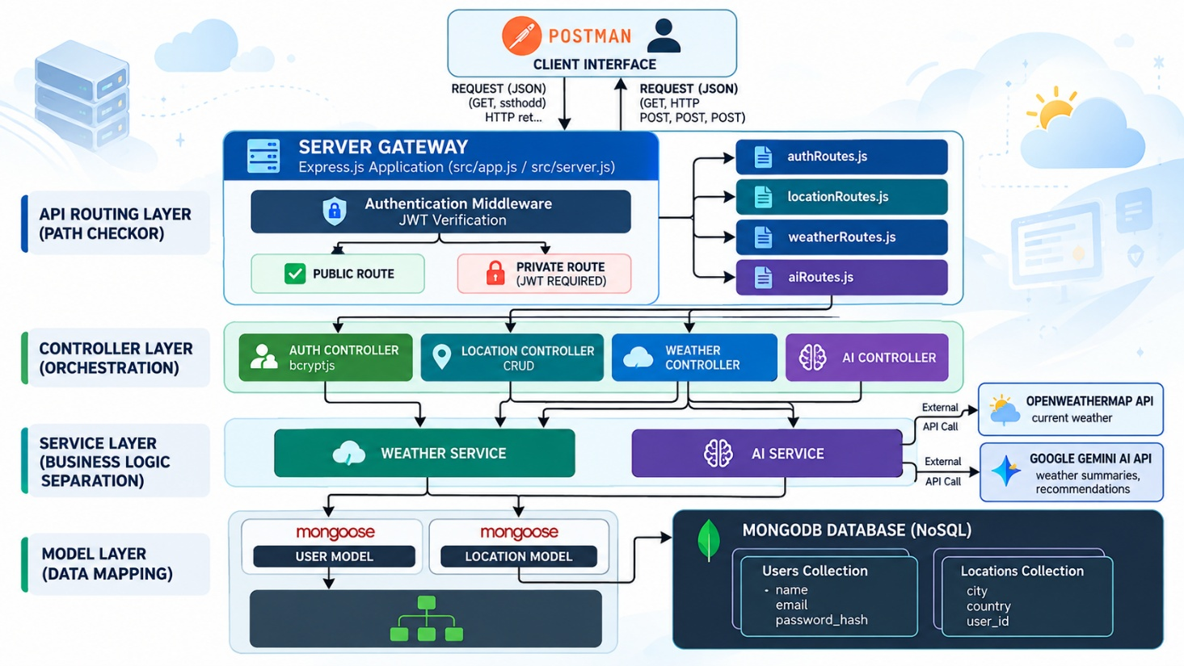

Architecture
The AI WeatherWise application follows the MVC (Model–View–Controller) architecture to maintain a clear separation between application logic, data management, and API communication. The Controller layer coordinates requests between the API routes and services, while the Model layer manages User and Location data through Mongoose. The service layer handles external weather and AI integrations, making the system modular, maintainable, and easier to extend.

Components Definition

Interface: API tools such as Postman are used to send HTTP requests to specific route paths and receive structured JSON responses for testing and verification.
Express Server Gateway: The Express.js server manages incoming HTTP requests, maps methods such as GET, POST, PUT, and DELETE, processes JSON request bodies, and handles cross-origin requests through CORS configuration.
Authentication Middleware: The authentication middleware extracts JWT tokens from request headers and verifies their validity before allowing access to protected resources. This ensures that only authenticated users can access secured operations.
Controller Layer: Controllers coordinate application requests and responses. Separate controllers handle authentication, favorite locations, weather information, and AI-powered operations, keeping the application logic organized.
Granular Services (Logic Modules): The service layer separates core business logic from controllers. The Weather Service communicates with the OpenWeatherMap API to retrieve current weather information, while the AI Service communicates with Google Gemini to generate summaries and recommendations.
Database Interface Layer: Mongoose ODM provides a structured interface between the application and MongoDB. It defines schemas, validates data, and performs database operations for users and favorite locations efficiently.
AI Service Integration: The Google Gemini AI SDK (@google/generative-ai) processes weather information and generates natural-language summaries and personalized recommendations based on current temperature and environmental conditions.
External API Integration: The system connects with OpenWeatherMap to obtain live weather data and with Google Gemini AI for intelligent analysis. This integration allows AI WeatherWise to combine real-time information with meaningful recommendations.
Error Handling and Fallback: Centralized error handling provides consistent responses when requests fail or external services become unavailable. The fallback mechanism helps maintain essential application functionality even when external API services cannot be accessed.Entity-Relationship (ER) Diagram Description
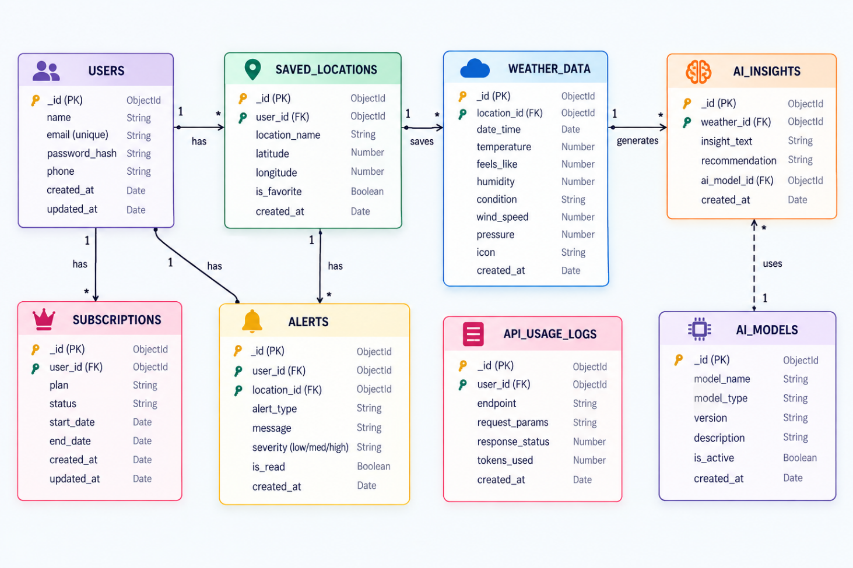
The data architecture manages User profiles and their associated favorite Locations through logical references:
1. User Entity
The User Entity stores registered user and authentication information.
_id (Primary Key – ObjectId): Unique identifier for each user.
name (String, Required): Stores the user's name.
email (String, Required, Unique): Stores a unique email address for authentication.
password (String, Hashed, Required): Stores the user's password in encrypted/hashed form.
role (String, Default: "reader"): Defines the user's access level.

2. Location Entity
The Location Entity stores the favorite cities saved by registered
_id (Primary Key – ObjectId): Unique identifier for each location.
user (Foreign Key referencing User Collection): Links the location to its respective user.
city (String, Required): Stores the selected city name.
country (String, Required): Stores the corresponding country.
createdAt (Date, Default: Now): Records when the location was added.

Key Structural Mappings
User to Location (One-to-Many): A registered user can save and manage multiple favorite locations.
Key Features
Secure Authentication: JWT authentication protects private API routes.
Password Protection: Bcrypt hashing secures user passwords.
Favorite Location CRUD: Users can add, view, update, and delete saved locations.
Real-Time Weather: Retrieves current weather information for selected cities.
AI Weather Insights: Google Gemini generates weather summaries and personalized recommendations.
Sanitization Safeguards: Validates and sanitizes request data to improve application security.
Fallback Support: Maintains basic functionality when external services are unavailable.

Roles and Responsibilities
Admin
Monitors API health and overall system performance.
Verifies weather, AI, authentication, and database integrations.
Oversees system and database integrity.
Registered User
Manages their account and favorite locations.
Requests real-time weather information.
Receives AI-generated weather summaries and recommendations.
Uses secured APIs through JWT authentication.
User Flow:
- User logs in or registers.
- User saves a favorite city via the API.
- User fetches current weather metrics for that city.
- User requests AI-driven insights (summaries/recommendations) based on the weather data.
- System validates JWT and returns the requested information.
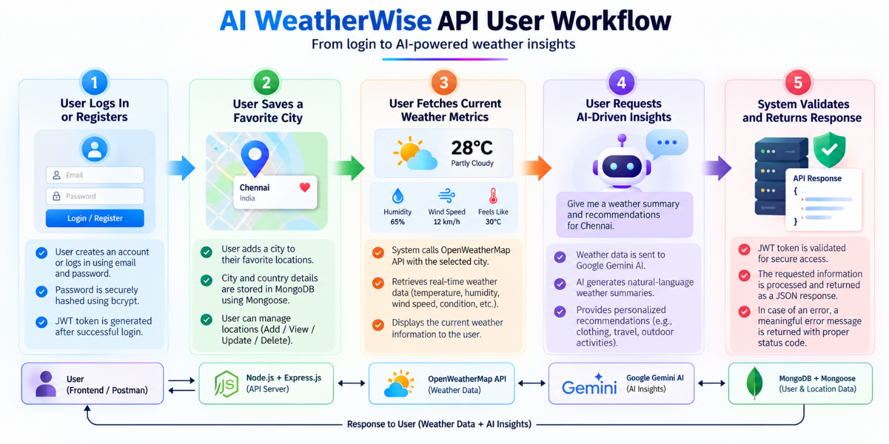

MVC Architecture Pattern
The system architecture structures its source configuration layers around the Model-View-Controller design pattern to completely decouple components:
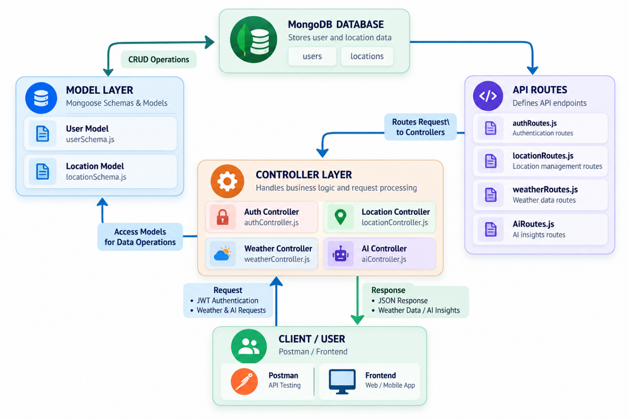

Model Layer (Data Blueprint)
Defines the data structure using Mongoose schemas that represent User and Location records in MongoDB. It specifies required fields, data types, default values, and validation rules to ensure that stored information remains consistent and reliable. The Model Layer also handles database operations such as creating, retrieving, updating, and deleting records..

Controller Layer (Execution Matrix)
Acts as the main processing layer between API routes, services, and database models. It receives incoming requests, processes the required parameters, performs authentication checks where necessary, and delegates operations to the appropriate services or models. After processing, it prepares and returns structured JSON responses to the client.

View Layer (Routing Network Interface)
Since AI WeatherWise is a headless RESTful backend, it does not contain traditional HTML-based views or user-interface templates. Instead, the API Routing Layer acts as the interface between clients and controllers. It maps HTTP requests to appropriate controller functions for authentication, location management, weather retrieval, and AI-powered operations.
Epic 2: Project Setup and Configuration Creating the Project Folder
- Create a new folder named AI Weatherwise
- Open the project folder in Visual Studio Code.
- Initialize the project using Node.js and install the required dependencies.

Project Initialization
Open the project folder in the VS Code terminal and execute:
npm init -y
Install the required dependencies:
npm install express mongoose bcryptjs jsonwebtoken cors dotenv multer @google/genai
Install Nodemon for development:
npm install --save-dev nodemon

Create the Following Files
- index.js
- .env
- package.json
- .gitignore

Create the Following Folder Structure

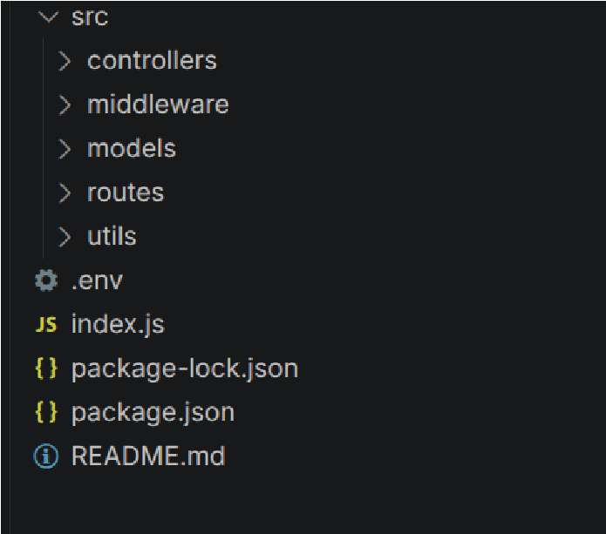

Environment Configuration
Create a .env file in the project root and configure the required environment variables.
PORT=5000
MONGO_URI=your_mongodb_connection_string
JWT_SECRET=your_jwt_secret GEMINI_API_KEY=your_gemini_api_key

Epic 3: Backend Development
The AI weatherwise backend is developed using Node.js, Express.js, and MongoDB, following a modular architecture. The application separates routing, controllers, middleware, models, and utility modules to improve code maintainability and scalability. The backend exposes secure REST APIs for authentication, study material management, AI-powered content generation, and administrative operations.
Backend Structure:
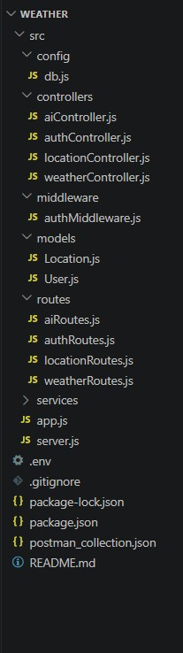

Core System Script Implementations

1. Application Entry Point (index.js)
The index.js file serves as the main entry point of the application. It initializes the
Express server, loads environment variables, configures middleware, establishes the MongoDB connection, registers API routes, and starts the server after a successful database connection.
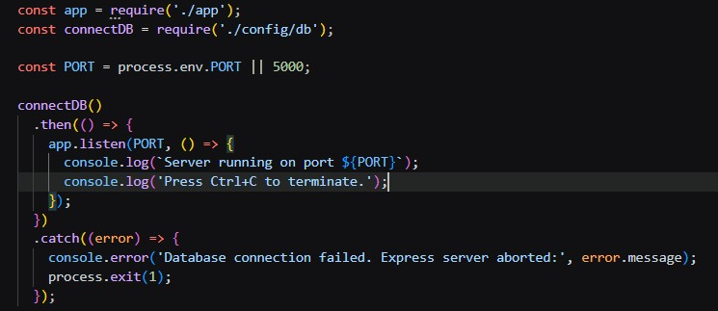

Epic4: Database Configuration

API Testing Demo :

1. Configure MongoDB:

- Install Mongoose.
In your Node.js project directory, run:
npm install mongoose ● Create database connection.
- Create Schemas & Models.

Create Database connection:
Now, make sure the database is connected before performing any of the actions through the backend. The connection code looks similar to the one provided below

Mongoose Schema Definitions
Location Schema:
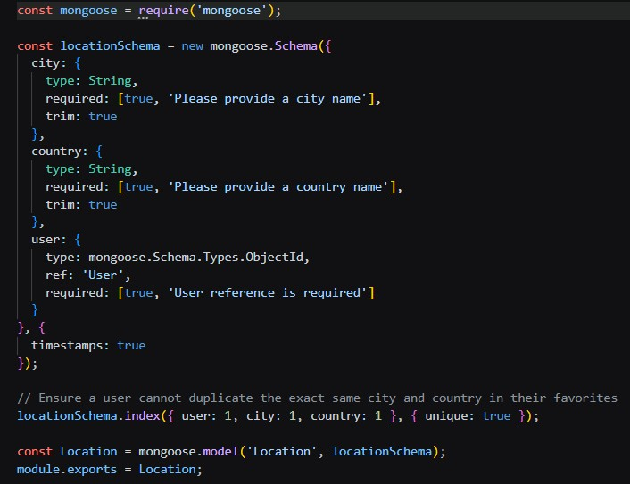

User schema:
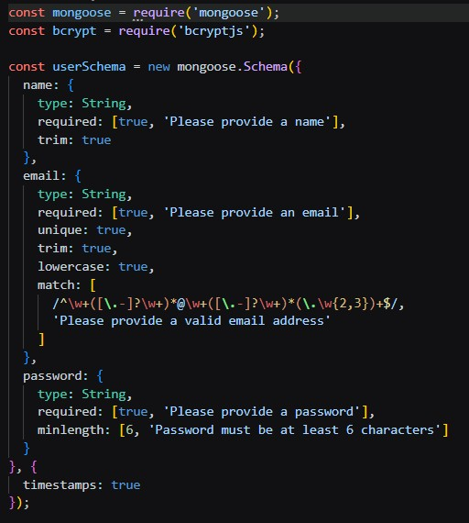
Db connection:
This module establishes a connection between the application and MongoDB using Mongoose. It ensures that the backend communicates with the database before processing any client requests.

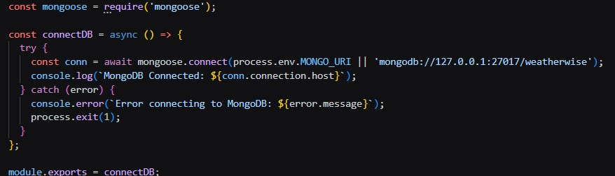

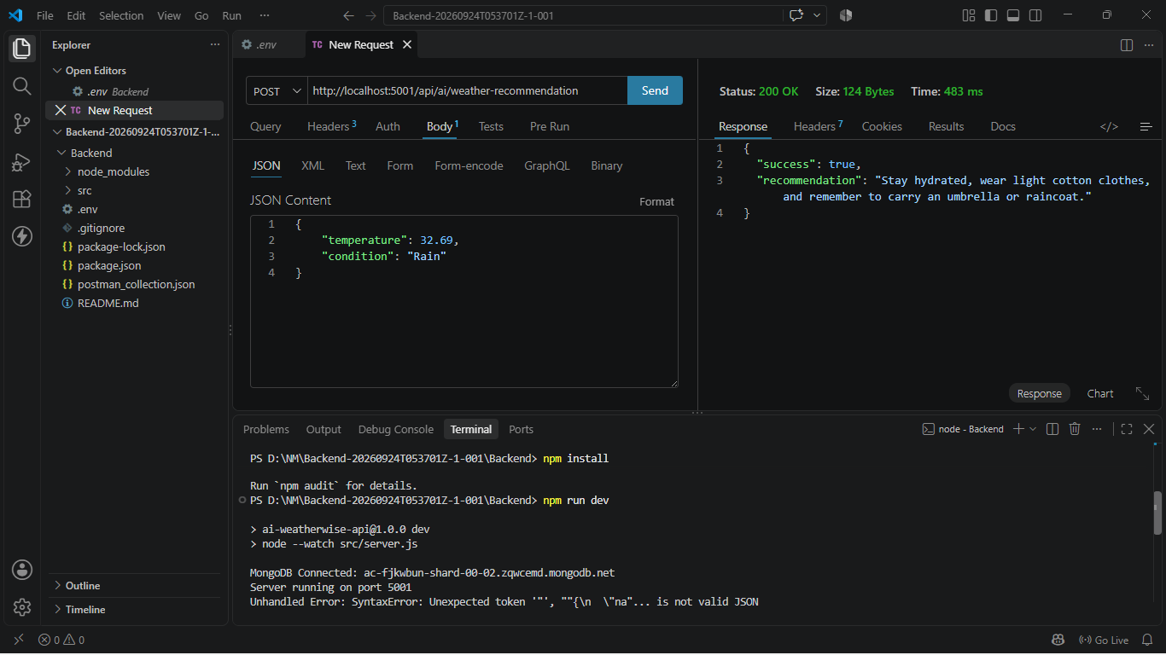

Epic 5: Project Executions:
The AI weatherwise backend can be executed locally using Node.js. Before running the application, ensure that MongoDB is running and the required environment variables are configured correctly. The backend exposes REST APIs that can be tested using Postman or Thunder Client. Running the Backend Server
Install all required dependencies:
npm install
Start the development server:
npm start
After successful execution, the server connects to MongoDB and starts listening for incoming API requests.

API testing: Register API:
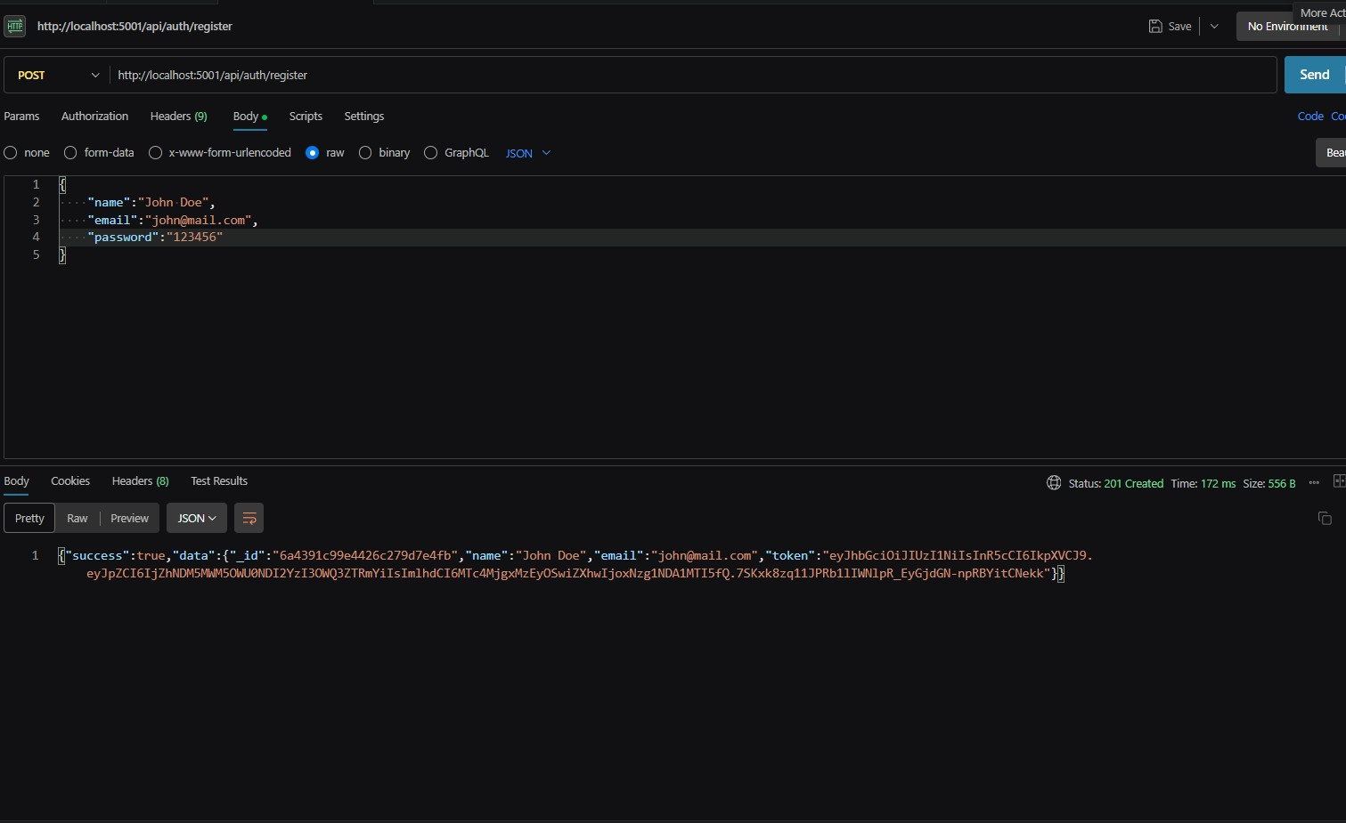 Login API:
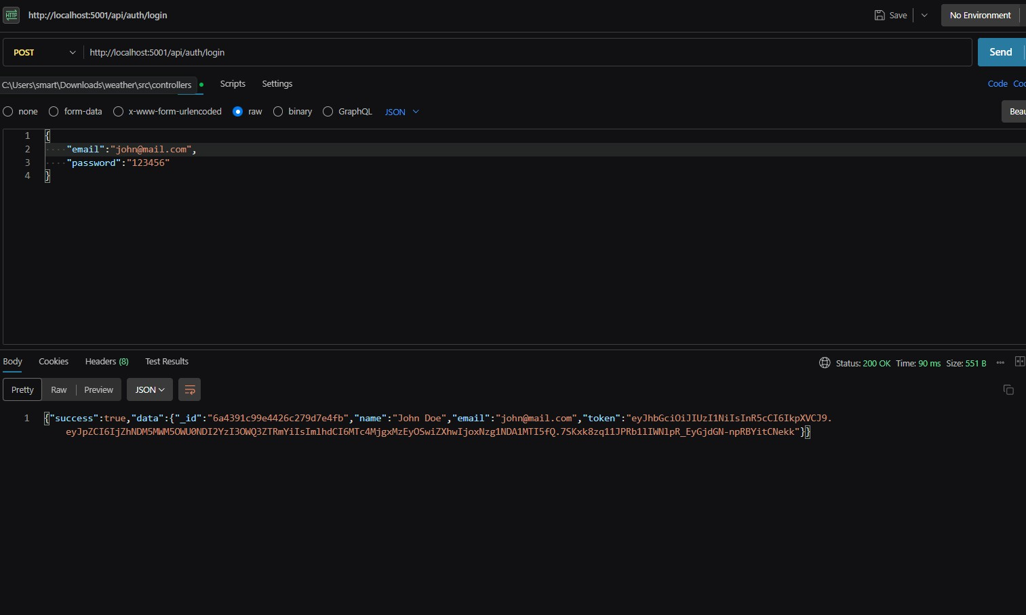
Weather API:
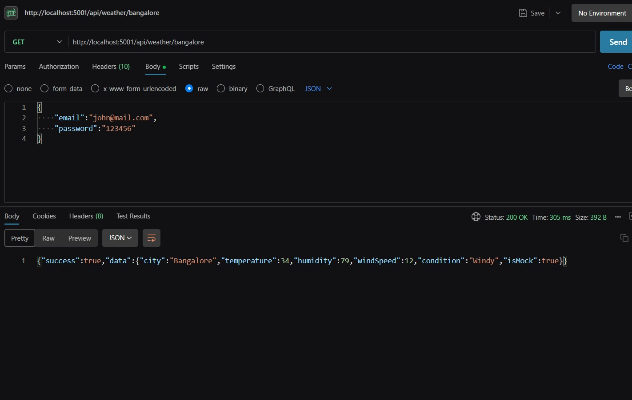

Recommendation API:

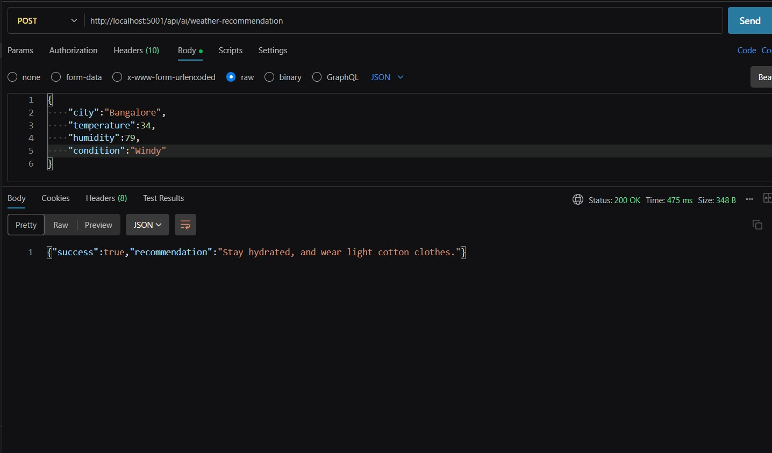

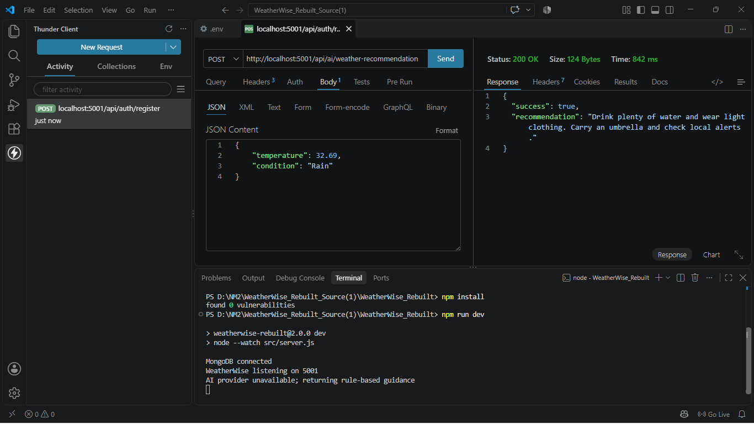

AI WEATHERWISE GITHUB LINK: https://github.com/hemanthsahoo18/NM-WeatherWiseAI.git
DEMO VIDEO OR OUTPUT VIDEO LINK: https://drive.google.com/file/d/1x19pEBLyR0vZ6RTgfXGJyQGfYH0UnHGD/view?usp=drive_link

